# Other ways to write code:

# Input in C++:

# Practice:

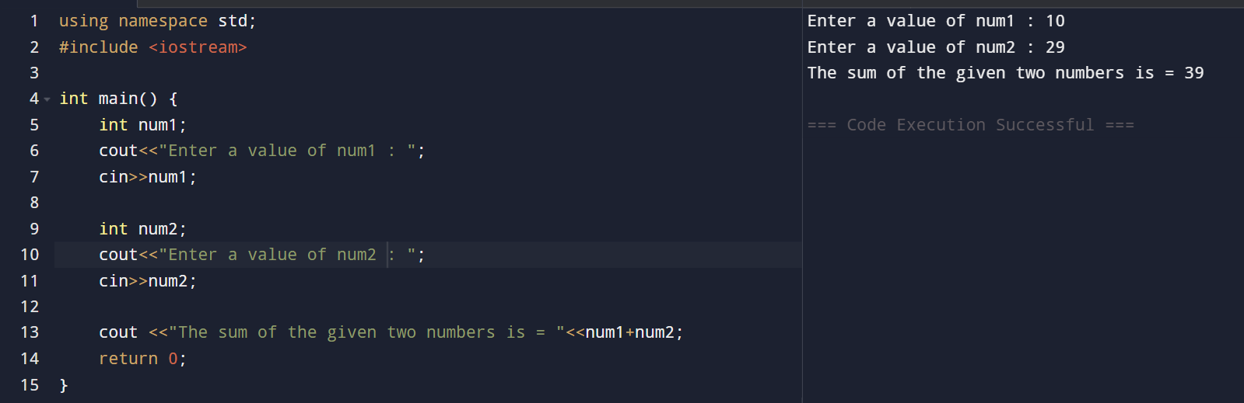

Cout is used for output while cin is used for input

<< is insertion operator, only used with cout. On the other hand, >> is extraction operator which is used with cin only.

# Task 01 :

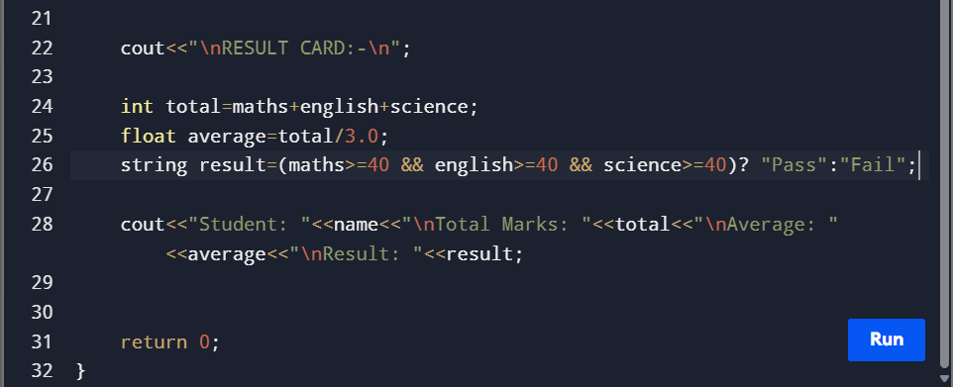

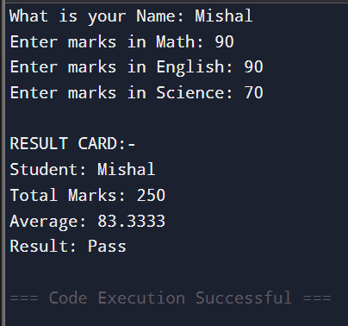

Task 02: 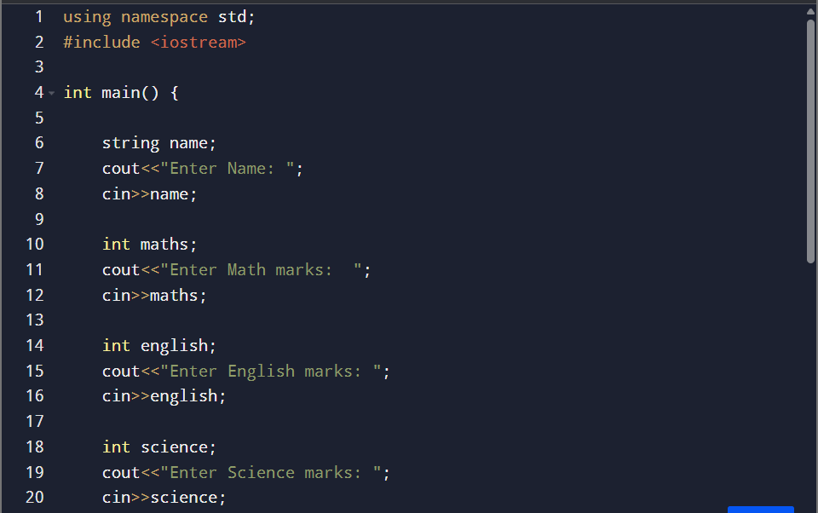

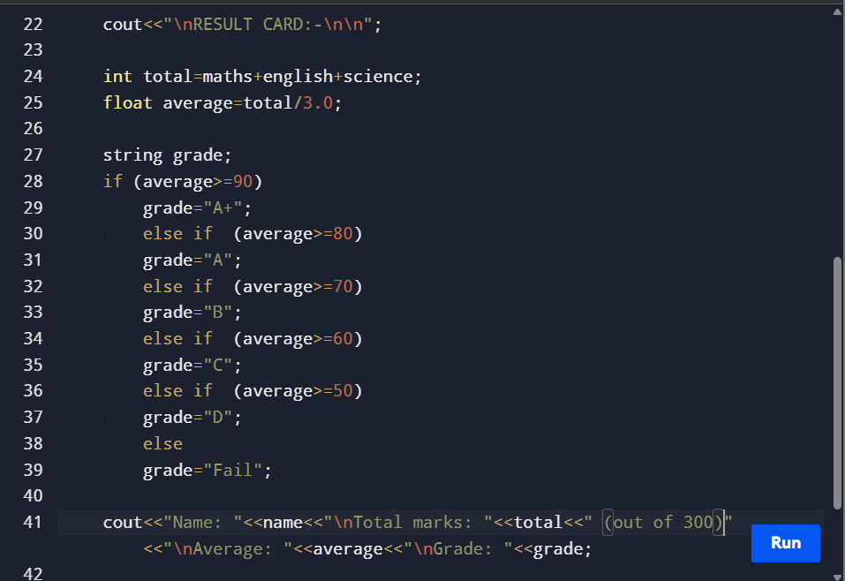

# Task 03:

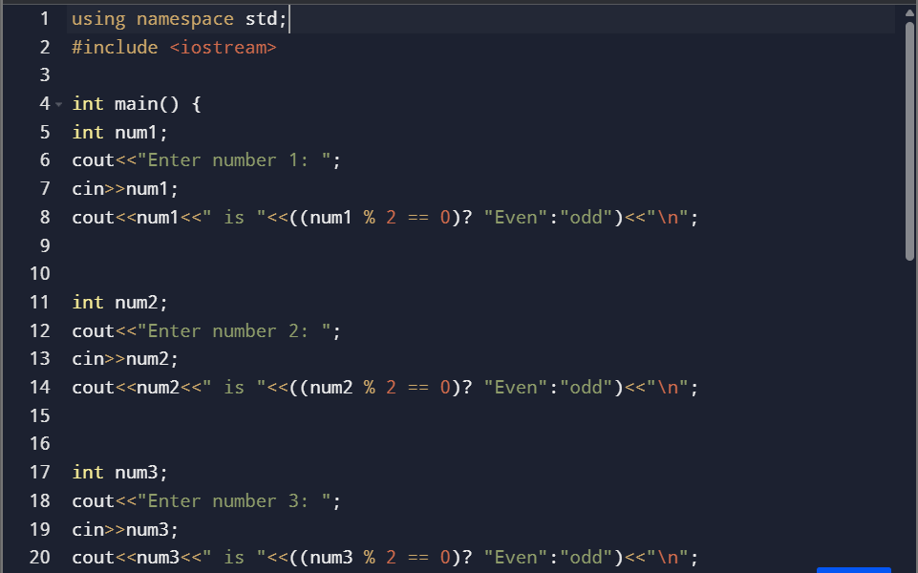

# Task 04:

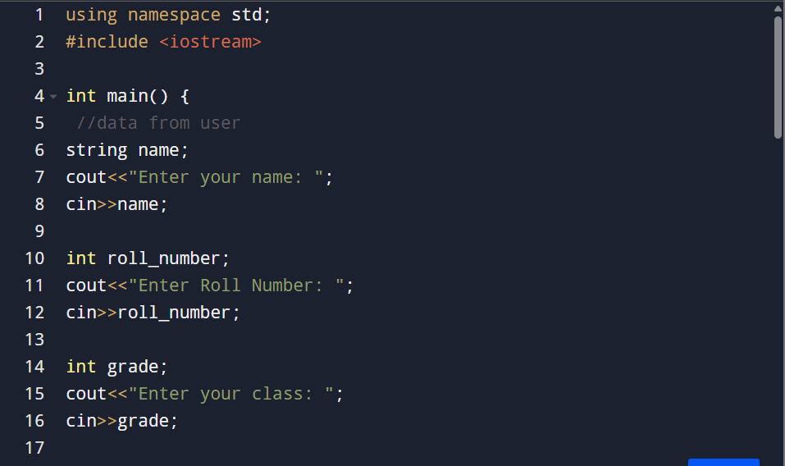

Output:

# Use of Boolean :

